Key Concepts and Insights
Service Account Definition:
Automation identity perspective (outside cluster view)- A service account in Kubernetes is a special type of user account intended for non-human entities such as applications, bots, or automation processes. Unlike human users who log in interactively, service accounts are used by automated workloads to authenticate with the Kubernetes API. Tools like Jenkins, Prometheus (external instance), or Datadog agents may run outside Kubernetes (on VMs, bare metal, or SaaS). They still need to authenticate to the Kubernetes API server. Instead of a human kubeconfig, they use a ServiceAccount token (just like Pods do). You can: Create a ServiceAccount in the cluster. Bind it to Roles/ClusterRoles with the required permissions. Extract its token (from the Secret or via kubectl create token in newer versions). Configure the external app to use that token + cluster ca.crt to talk to the API server.
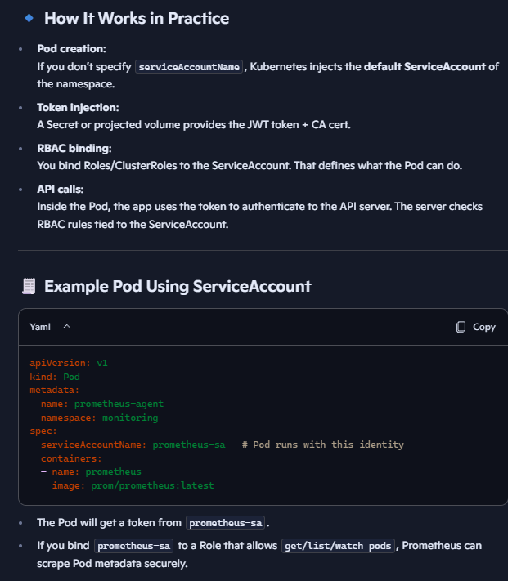
From the Pod’s perspective (in-cluster view)–
ServiceAccount is the Pod’s identity in the cluster. When you run a Pod, Kubernetes automatically associates it with a ServiceAccount (default or custom) in its namespace. That ServiceAccount’s credentials (JWT token + ca.crt) are mounted into the Pod at /var/run/secrets/kubernetes.io/serviceaccount/. This means the Pod has an identity it (or the application inside the Pod) can use to talk to the Kubernetes API server. Example: a Pod running Prometheus can use its ServiceAccount identity to query /api/v1/nodes or /api/v1/pods if RBAC allows.

Types of Users in Kubernetes:
  - Human users: Team members or operators who access the cluster for administrative or operational tasks.
  - Service accounts: Automation users used by applications like Jenkins (CI/CD), monitoring tools like Prometheus, or third-party integrations like Datadog. These workloads don’t log in interactively — they use the ServiceAccount token to authenticate securely.
Why Use Service Accounts?
  - Automation processes should not run under individual human user credentials for security and auditability reasons. Service accounts provide a secure, programmatic way to authenticate and authorize bots or applications. Using service accounts ensures that roles and permissions are scoped to automation, reducing risks associated with personal user credentials.
Default Service Account:
Each namespace in Kubernetes automatically has a default service account created, which has limited permissions. These accounts, by default, no longer auto-generate tokens/secrets due to recent Kubernetes security updates (post v1.24). Tokens are ephemeral and projected directly into Pods via a volume mount. If you need a long-lived token for external use, you explicitly create one.
kubectl create token app-sa -n demo-ns
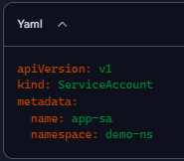
Creating a New Service Account:
Using kubectl create serviceaccount <name -n demo-ns> creates a new service account in a specified namespace (default if none given). Newly created accounts initially do not have tokens or secrets attached.
Service Account Tokens and Secrets:
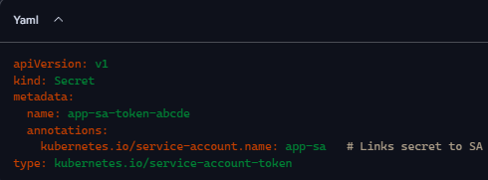
  - Tokens are required for API authentication. Without a token you can’t authenticate and as only HTTPS is supported for Kubernetes API communication, so without ca.crt, you cannot securely establish the TLS connection.
  - You can create a long-lived API token manually by creating a secret of type kubernetes.io/service-account-token and annotating it to bind to the service account.
  - These tokens allow the service account to authenticate and make API calls programmatically.
kubectl describe secret app-sa-token-abcde -n demo-ns shows this info:
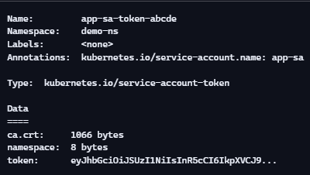
  - The ca.crt is the cluster’s Certificate Authority (CA) certificate. It allows the Pod or external app (using this ServiceAccount) to verify the identity of the Kubernetes API server when making HTTPS requests. Without ca.crt, the Pod or external app couldn’t trust the API server’s TLS certificate. The token is a JWT used for authentication, and the namespace field tells which namespace the SA belongs to.
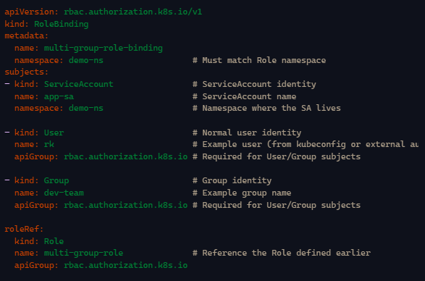
Role and RoleBinding for Service Accounts:
Permissions for service accounts are granted using the same RBAC constructs as for human users:
  - Create a Role specifying allowed verbs (e.g., list, get, watch) and resources (e.g., pods).
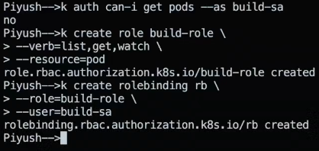
  - Bind the Role to the service account using a RoleBinding.
This enables service accounts to perform actions on the cluster securely and with defined scope. Can create using imperative way:

Image Pull Secrets:
  - Used to authenticate when pulling container images from private registries such as Docker Enterprise Hub, Artifactory, JFrog, AWS ECR, Azure ACR, or Google GCR.
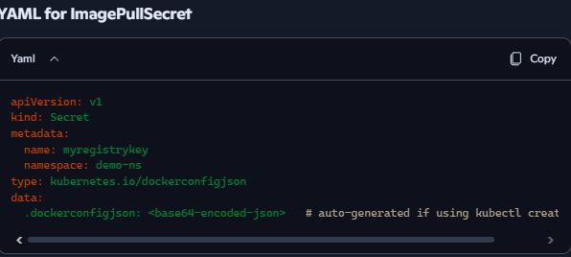
  - Secrets store credentials securely and are referenced in Pod specs or attached to service accounts to enable image pulls without exposing plaintext passwords.
Imperative:
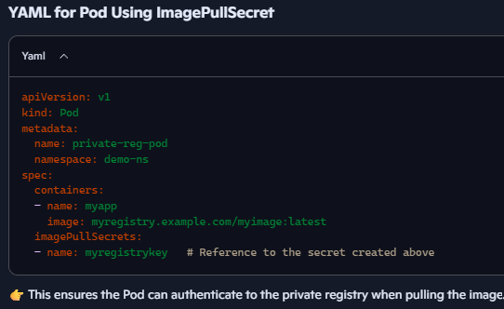
kubectl create secret docker-registry myregistrykey \
--docker-server=myregistry.example.com \
--docker-username=myuser \
--docker-password=mypassword \
--docker-email=myuser@example.com \
-n demo-ns

Mounting Tokens in Pods:
  - Service account tokens are mounted into Pods as volumes under /var/run/secrets/kubernetes.io/serviceaccount.
  - This mounting is a best practice for secure access, avoiding injecting secrets directly into containers.
  - Mounted files typically include token, namespace, and ca.crt.

Important Commands and Concepts
Command / Concept | Description
kubectl get sa | List service accounts in the cluster or namespace.
kubectl create serviceaccount <name> | Create a new service account in the current namespace.
kubectl describe sa <name> | View details of a service account.
Creating a secret YAML of type service-account-token | Manually create a token secret for long-lived service account authentication.
kubectl create role <name> --verb=list,get,watch --resource=pods | Create a Role with permissions to list, get, and watch pods.
kubectl create rolebinding <name> --role=<role> --user=system:serviceaccount:<namespace>:<sa> | Bind a Role to a service account for permissions.
Mount location of service account tokens | /var/run/secrets/kubernetes.io/serviceaccount inside Pods.
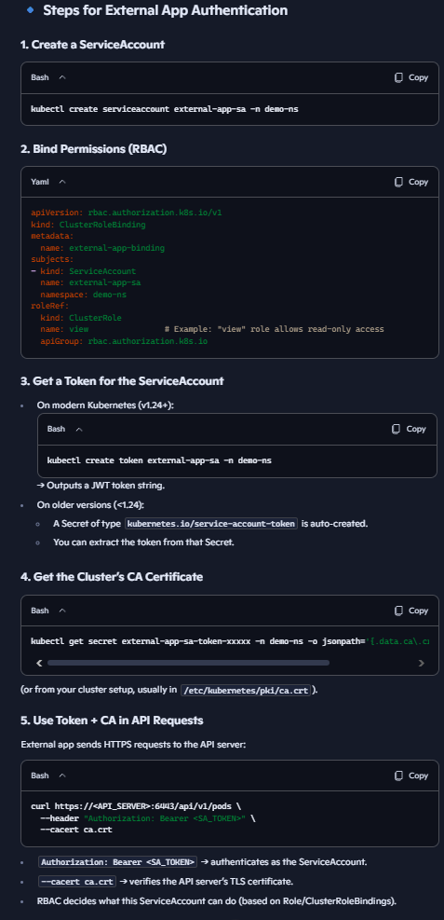
Roles and RoleBindings control the permissions service accounts have, ensuring least privilege access.

Human users typically authenticate with a kubeconfig that contains a client certificate/key or OIDC token.
Automation apps instead use a ServiceAccount token (JWT) + the cluster’s CA certificate to authenticate directly against the Kubernetes API server. No kubeconfig, no user cert/key required — just the token and CA.

